JEFF BEARDEN, SUPERINTENDENT BIG CREEK 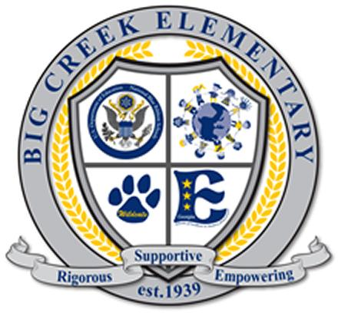

COURTNEY McKINNEY, PRINCIPAL ELEMENTARY SCHOOL

KATIE TURNER, ASSISTANT PRINCIPAL

HEATHER SMITH, ADMINISTRATIVE ASSISTANT

Dear Potential Business Partner,

At Big Creek Elementary, we are committed to ensuring a strong foundation of excellence for all students. Families, businesses, and the community at large contribute greatly to the success of Big Creek. We are currently inviting our business partners to commit to supporting our school for the 2022-2023 academic year through involvement in the Partners in Education Program. Business Partners have opportunities to support the school through monetary donations as well as through resources and services. The four key areas of partnership as outlined by Forsyth County Schools include - Improving Academic Performance, Providing for Educator Support and Morale, Enriching the Life Experience of Students, and Growing Career Opportunities.

Thank you for considering the information on the following pages about the ways that you can support our school through our Partners in Education program. Your support is vital and a key component to helping us build a stronger community and supporting greater educational opportunities for our students.

Below are just a few of the ways that Partners in Education can get involved:

* Sponsor academic extracurricular events -- Spelling Bee, Oratorical Contest, etc.
* Support our Media Center -- donations to purchase books, furniture, bookshelves, etc.
* Support staff recognition events --Employee of the Month, Teacher of the Year, faculty meetings
* Sponsor a student recognition program – Student of the Month Award, school clubs, chorus, etc.
* Provide monetary donations for our STEM lab supplies, PE equipment, and other instructional resources for our students.
* Sponsor a school-wide event -Veteran’s Day, Teacher Appreciation Week, STEM Night, Literacy Night, Kindergarten Orientation, etc.
* Provide scholarships for students in need for field trips, activities or events

If you have any additional questions or concerns, please contact our Partners in Education coordinators, Katie Turner or Aditi Tolia-Pande. We are excited about the opportunity of partnering with you!

Sincerely,

Katie Turner & Aditi Tolia-Pande

Katie Turner Aditi Tolia-Pande

[Kturner@forsyth.k12.ga.us](mailto:Kturner@forsyth.k12.ga.us) [f40996@forsyth.k12.ga.us](mailto:f40996@forsyth.k12.ga.us)

770-887-4584 (ext. 710125) 770-887-4584 (ext. 711120)